**Week 7**

**9. ReactJS – HOL**

**FILE STRUCTURE  
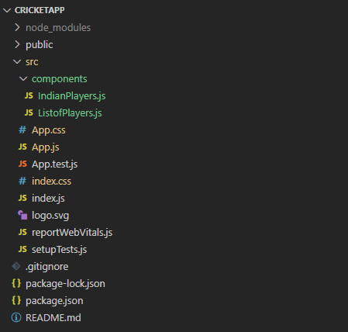**

**CODE**

*C:\Users\User\Desktop\cricketapp\src\components\IndianPlayers.js*

import React from 'react';

const IndianPlayers = () => {

  const team = ['Sachin1', 'Dhoni2', 'Virat3', 'Rohit4', 'Yuvaraj5', 'Raina6'];

  const [first, , third, , fifth] = team;

  const [, second, , fourth, , sixth] = team;

  const T20Players = ['First Player', 'Second Player', 'Third Player'];

  const RanjiTrophyPlayers = ['Fourth Player', 'Fifth Player', 'Sixth Player'];

  const mergedPlayers = [...T20Players, ...RanjiTrophyPlayers];

  return (

    <div>

      <h2>Odd Players</h2>

      <ul>

        <li>First : {first}</li>

        <li>Third : {third}</li>

        <li>Fifth : {fifth}</li>

      </ul>

      <hr/>

      <h2>Even Players</h2>

      <ul>

        <li>Second : {second}</li>

        <li>Fourth : {fourth}</li>

        <li>Sixth : {sixth}</li>

      </ul>

      <hr/>

      <h2>List of Indian Players Merged:</h2>

      <ul>

        {mergedPlayers.map((player, index) => (

          <li key={index}>Mr. {player}</li>

        ))}

      </ul>

    </div>

  );

};

export default IndianPlayers;

*C:\Users\User\Desktop\cricketapp\src\components\ListofPlayers.js*

import React from 'react';

const ListofPlayers = () => {

  const players = [

    { name: "Jack", score: 50 },

    { name: "Michael", score: 70 },

    { name: "John", score: 40 },

    { name: "Ann", score: 61 },

    { name: "Elisabeth", score: 61 },

    { name: "Sachin", score: 95 },

    { name: "Dhoni", score: 100 },

    { name: "Virat", score: 84 },

    { name: "Jadeja", score: 64 },

    { name: "Raina", score: 75 },

    { name: "Rohit", score: 80 },

  ];

  const playersBelow70 = players.filter(player => player.score <= 70);

  return (

    <div>

      <h2>List of Players</h2>

      <ul>

        {players.map((item, index) => (

          <li key={index}>

            Mr. {item.name}<span> {item.score}</span>

          </li>

        ))}

      </ul>

      <hr/>

      <h2>List of Players having Scores Less than 70</h2>

      <ul>

        {playersBelow70.map((item, index) => (

          <li key={index}>

            Mr. {item.name}<span> {item.score}</span>

          </li>

        ))}

      </ul>

    </div>

  );

};

export default ListofPlayers;

*C:\Users\User\Desktop\cricketapp\src\App.js*

import React from 'react';

import ListofPlayers from './components/ListofPlayers';

import IndianPlayers from './components/IndianPlayers';

function App() {

  const flag = true;

  return (

    <div className="App">

      {flag ? <ListofPlayers /> : <IndianPlayers />}

    </div>

  );

}

export default App;

import React from 'react';

import ListofPlayers from './components/ListofPlayers';

import IndianPlayers from './components/IndianPlayers';

function App() {

  const flag = false;

  return (

    <div className="App">

      {flag ? <ListofPlayers /> : <IndianPlayers />}

    </div>

  );

}

export default App;

**OUTPUT**

